**Assignment 1.2:Unix Commands:**

* Pwd: to display current path:

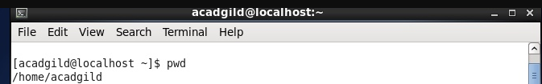

* Touch : commands to modify the access date/or create a temporary file of 0 byte.

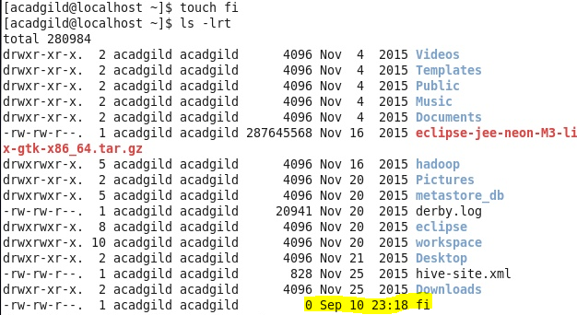

* Mkdir : creates a directory
* ls : list files/directory

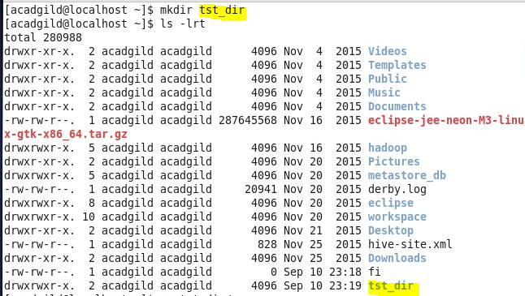

* Vi: an editor to read/write in a file
* cat: concatenate../add some thing in afile
* Rm : remove file

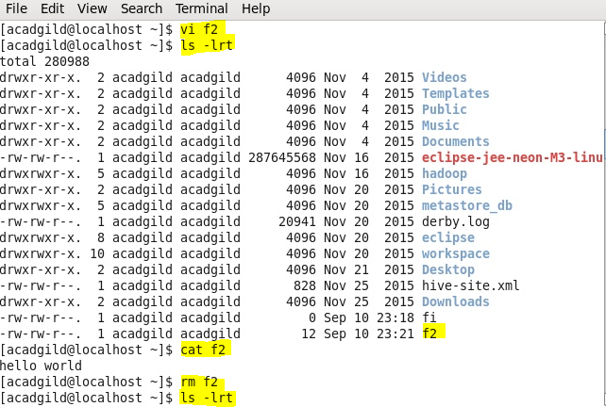

* echo : command to view/ display a contant of a fiile at stdout

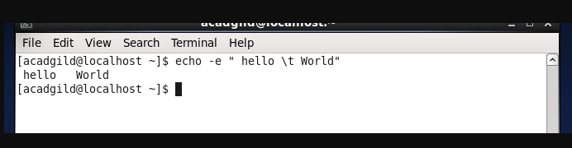

* who : to see all the users



* cd : change directory

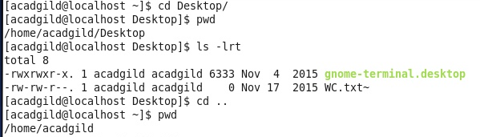

* date: display the system’s currant date /time
* cal: display the calender
* 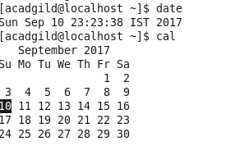
* mv: move a file from a location to another. File in source is deleted

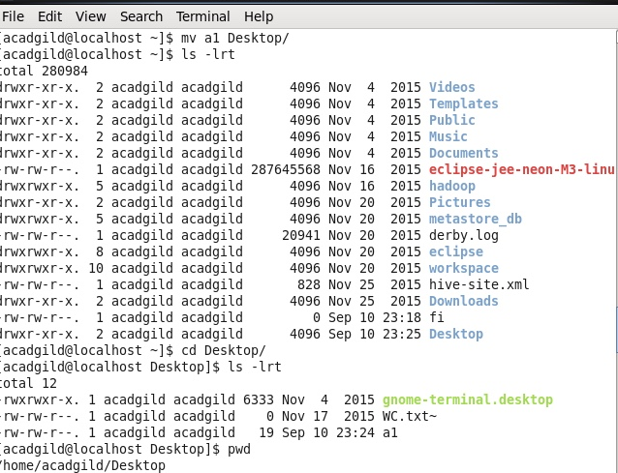

* cp : copy a file from a source to dest.

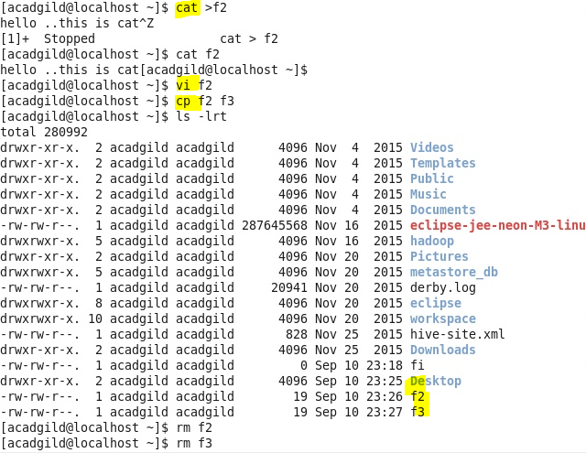

* Which: show the path of a executable/ command as per PATH variable

